Video Surveillance System via Motion Detection for Restricted Area’s

uom_logo

­

­Submitted by

Kamran khan (683)

Farhan khan (638)

BS Software Engineering

Session 2017-2021

Supervisor: Engr Zeeshan Danish

Department of Software Engineering

University of Malakand

Khyber Pakhtunkhwa, Pakistan

**Video Surveillance System via Motion Detection for Restricted Area’s**

**“Video Surveillance System via Motion Detection for Restricted Area’s”** is submitted in partial fulfillment of requirements for the degree of Bachelor in Software Engineering to the Department of Software Engineering University of Malakand.

Submitted by: Kamran khan (Enroll id: 687)

Farhan khan (Enroll id: 693)

Supervisor:

Chairman Department of Software Engineering:

Certificate of Approval

It is certified that we have studied this project report submitted by **Kamran khan** and **Farhan khan** in detail. We conclude that this report is of sufficient standard to warrant its acceptance by the department of Software Engineering for the award of the degree of BS in [Software Engineering].

Supervisor

Signature:

Name:

Designation:

External Examiner

Signature:

Name:

Designation:

Institute:

Chairman Software Engineering

Signature:

Name:

Declaration of Originality

We **Kamran khan** and **Farhan khan** are declaring that we have produced the work presented in this project report during the scheduled period of study. We also declare that we have not taken any material from any source except referred to wherever due.

Signature of the Students:

**Kamran khan**: \_\_\_\_\_\_\_\_\_\_\_

Date: \_\_\_\_\_\_\_\_\_\_\_

Registration No: 1706827

**Farhan khan**: \_\_\_\_\_\_\_\_\_\_\_\_\_\_\_\_

Date: \_\_\_\_\_\_\_\_\_\_\_\_\_\_\_\_\_\_\_\_\_

Registration No: \_\_\_\_\_\_\_\_\_\_\_\_

Acknowledgments

First of all, we are highly grateful to **Almighty Allah** for all the countless gifts you have offered us and established us for the successful completion of our project.

we would like to record my application to Engr:Zeeshan Danish for his continuous guidance and supervision throughout the thesis research. His valuable input helped us develop our idea and I achieved academic accomplishment through the research.

We would like to thanks our friends for their constant support, and ﬁnally our colleagues, who have been working with us on this project from day one; without their efforts and collaboration, indeed, this project would not have been completed.

*DEDICATION*

To our beloved family and all our teachers who supported us through here and our dedication to our special friends

Last but not least we are dedicating this to our beloved teacher late Engr: Nouman khan who has gone forever and left a void never to be filled in our lives. Though your life was short, we will make sure your memory lives on as long as we are alive. May Allah (SWT) grant you Jannah Firdaws.

Amen.

*Kamran khan and Farhan khan*

ABSTRACT

In today’s competitive environment, the security concerns have grown tremendously.

The current systems used in the fight against thefts and destruction are the video surveillance and monitoring. By using the technologies, it is possible to monitor and capture every inch and second of the area in interest. The current systems only store the video with out any automated process and can’t alerting the concerned authorities while any unusual activities takes palce.Therefore, we have developed a methodology to detect the motion in a video stream environment and store those frames in which motion is detected as a video and picture in local storage as well as on online storage.The proposed system also give an alert to the concerned authorities.

This is an idea to ensure that the monitoring systems not only actively participate in stopping the unusual activities, but do so while such activities taking place. We used Gaussian mixture-based background/ foreground segmentation algorithm. The process is simple, when an intruder enters the frame the algorithm will process and a tracking line will be formed around an intruder.Hence the system will not only detect the unusual activities but also store those frames plus alerting the concerned authorities.The redundant imaging techniques are excluded in the proposed system in order to minimize the computation time, which ultimately shorten the delay for a real-time implementation. This system will promote low delay but high performance real-time surveillance system.

KEYWORDS: Video surveillance system-Via-Motion detection, Moving object detection, Tracking, Background-subtraction, Storing video and pictures, Sending a Notification, Security system*,* online storage.

Table of Contents

[Chapter 1 8](#_Toc53682911)

[Introduction 8](#_Toc53682912)

[1.1 Overview of the Project 8](#_Toc53682913)

[1.2 Problem Statement 8](#_Toc53682914)

[1.3 Project Aim 9](#_Toc53682915)

[1.4 Intended users 9](#_Toc53682915)

[1.5 Methodology 10](#_Toc53682917)

[1.6 Project schedule 11](#_Toc53682918)

1.8 [Project report structure 11](#_Toc53682919)

1.9 [Conclusion 12](#_Toc53682918)

[Chapter 2 13](#_Toc53682919)

[Literature Review 13](#_Toc53682920)

[2.1 Related Research 13](#_Toc53682921)

[2.1.1 Surveillance system with computervision…………………...…………13](#_Toc53682921)

[2.1.2 Detection problem,Slow movement problem, deterioration problem …14](#_Toc53682921)

[Chapter 3 17](#_Toc53682922)

[Proposed System 17](#_Toc53682929)

[3.1 Introduction 17](#_Toc53682930)

[3.2 Requirement analysis 17](#_Toc53682931)

[3.1.1 Functional requirements 17](#_Toc53682932)

[3.1.2 Non-Functional Requirement 18](#_Toc53682933)

[Chapter 4 20](#_Toc53682935)

[Computer language and Tools 20](#_Toc53682937)

[5.1 Python 20](#_Toc53682937)

[5.2 Open-CV 20](#_Toc53682938)

[5.3 Twilio API 21](#_Toc53682939)

[5.4 Drop-box API 21](#_Toc53682940)

[5.5 Pycharm 21](#_Toc53682941)

Chapter 5……………………………………………………………………………..22

[Desgin and Implementation 22](#_Toc53682950)

[5.1 Introduction 22](#_Toc53682942)

[5.2 Flow chart 22](#_Toc53682943)

[5.3 Required Permissions 23](#_Toc53682944)

[5.4 User Interface of Application 25](#_Toc53682945)

[5.5.5 Video capturing 26](#_Toc53682946)

[5.6 Interface of Intruder Detected 27](#_Toc53682947)

[5.7 Background subtraction with contours Detection 28](#_Toc53682948)

[5.8 Pictures saved in local storage 29](#_Toc53682948)

[5.9 video saved in local storage 30](#_Toc53682948)

[5.10 Online storage 31](#_Toc53682948)

[5.1.1 Sending Notification alerts 33](#_Toc53682948)

[Chapter 6 34](#_Toc53682949)

[Testing and Evaluation 34](#_Toc53682950)

[6.1 Software testing 34](#_Toc53682951)

[6.2 Different types of Software testing 34](#_Toc53682952)

[6.3Load video testing 34](#_Toc53682953)

[6.4 Black-box testing 34](#_Toc53682954)

[6.5 End To End Testing 35](#_Toc53682955)

[6.6 Functional Testing 35](#_Toc53682955)

[6.7 Non Functional -testing 35](#_Toc53682957)

[6.8Performance -testing 35](#_Toc53682957)

[6.9 Security -testing 35](#_Toc53682957)

[6.10 Unit-testing 36](#_Toc53682957)

[6.1.1 Integration -testing 36](#_Toc53682957)

[6.1.2 White-box -testing 36](#_Toc53682957)

[6.1.3 System -testing 36](#_Toc53682957)

[Chapter 7 37](#_Toc53682958)

[Conclusion and Future Work 37](#_Toc53682959)

[7.1 Conclusion 37](#_Toc53682960)

[7.2 Future Work 38](#_Toc53682961)

[References 39](#_Toc53682962)

[Copyrights Notice 41](#_Toc53682963)

List of Tables

[Table No 1 Project Gantt chat………………………………………………………11](#_Toc53477621)

List of Figures

[Figure 1 V-Model 10](https://d.docs.live.net/40cc8b38ea5295f7/FYP/FYP%20Thesis/thesis/Final%20thesis.docx#_Toc53481337)

[Figure 2 Flow chart of the proposed system 22](https://d.docs.live.net/40cc8b38ea5295f7/FYP/FYP%20Thesis/thesis/Final%20thesis.docx#_Toc53481337)

[Figure 3 Required permissions For different camera 23](#_Toc53481338)

[Figure 4 Required permissions For accessing local storage 24](#_Toc53481339)

[Figure 5 User interface 24](https://d.docs.live.net/40cc8b38ea5295f7/FYP/FYP%20Thesis/thesis/Final%20thesis.docx#_Toc53481340)

[Figure 5.1 User interface 25](https://d.docs.live.net/40cc8b38ea5295f7/FYP/FYP%20Thesis/thesis/Final%20thesis.docx#_Toc53481340)

[Figure 6 Video capturing 26](#_Toc53481341)

[Figure 7 Interface with an intruder detected 27](#_Toc53481342)

[Figure 7.1 Interface with an intruder detected 27](#_Toc53481342)

[Figure 8 Background Subtraction with contours 28](#_Toc53481343)

[Figure 8.1 Background Subtraction with contours 28](#_Toc53481343)

[Figure 9 Pictures Saved in local storage 29](#_Toc53481344)

[Figure 10 Videos Stored in a local storage 30](#_Toc53481345)

[Figure 11 online storage 31](#_Toc53481346)

[Figure 11.1 Saved pictures in Drop-box 32](#_Toc53481347)

[Figure 12 Notification alert from Twilio 33](#_Toc53481347)

ACRONYMS AND ABBREVIATIONS

SS: Surveillance system

CV: Computer vision

BGS: Background subtraction

AI: Artificial Intelligence

SRC: Source

RGB: Red green blue

AVI: Audio Video Interleave

UI: User Interface

API: Application Programming Interface

IDE: Integrated Development Environment

UML: Unified Modeling Language

# Chapter 1

# Introduction

This chapter describes the basics of the project including our aim.

## 1 Overview of the Project

Over the years, security systems have been compromised with the increase in technology developments, It is essential to have a system that can not only watch over but also record any unusual movement and also able to send an alert to the concerned authorities when an intruder is detected.

The system will also take the picture of the intruder and send it to online storage which will be accessible by a link sent with an alert message. Also, a video will be captured from the time when an intruder enters the frame until the intruder leaves the frame, the video will be stored on local disk storage.

## 1.2 Problem Statement

Infrastructure growth has been noticeable in security-related challenges around the world during the previous few decades. As a result of the rising demand for security, people detection and tracking has become one of the most important study disciplines in recent years. Although commercially viable human detection and counting technologies exist today, more research is needed to solve the challenges of real-world scenarios. There are a lot of surveillance cameras installed around us but there is no means to monitor all of them continuously. It is necessary to develop computer vision-based technologies that automatically process those images to detect problematic situations or unusual behavior. Video surveillance system-Via-Motion

Detection addresses real-time observation of people within a busy environment leading to the description of their actions and interactions. It requires the detection and tracking of people to ensure security, safety, and site management. Intruder detection is one of the fundamental steps in video surveillance. The main aim of the video surveillance system-Via-Motion detection here is, to detect and track an object in motion by using a camera. If a Moving object entity is detected the tracking lines are formed around that and the object is tracked. The system when realizes the Moving object entry, it is processed in a second, and the alert is produced for the security purpose. Also, a Notification will be sent to the concerned authorities.

## 1.3 Project Aim

The main objective of this project is to improve the security system in sensitive and restricted areas.

* To avoid unusual activities in sensitive areas.
* To provide sufficient tools to the security authorities to eliminate security risks.
* To detect motion in remote areas where human access is difficult.
* To alert the concerned authorities incase of detection of unusual activity.
* Will take pictures when detecting motion and unusual activity.
* Notification will be sent to the concerned authorities when a motion is detected.

Aim: In our project, we have aimed to build such a surveillance system, which can not only detect motion but will also:

* Warn the user of the intrusion.
* Record the footage of the video from the moment the motion was detected.
* Send Notification to the user when the Motion is Detected.

## 1.4 Intended Users

Our system is based on a critical surveillance system which would be used in restricted areas like high authorities offices which contain sensitive information, Also

could be used in educational secrecies, commercial places where surveillance is needed, Houses and car parking and much more. In short the system, we propose can be used for any kind of surveillance system but mostly focused on the above-mentioned areas.

## 1.5 Methodology

There are several approaches and models for the development of software products. We have used V model also known as verification and validation model for the development of a video surveillance system via motion detection for restricted areas.V Model was developed to improve the efficiency and effectiveness of software development, the model was accepted both in Europe and Asia as an alternative to the waterfall model.V model is a step-by-step process in which the next phase begins only after the completion of the current phase, the steps in this process do not move linearly instead the step in this process are bent upwards. When this model is compared with the waterfall model, there are larger chances of emphasizing on products testing.If this model is used to test a product there is assurance that the final product developed will be of high quality. We used V model methodology to discord limitations of traditional development of the software product as well V model methodology we focus on delivering working software with high quality where no compromise could be made since it’s based on the critical security system.

[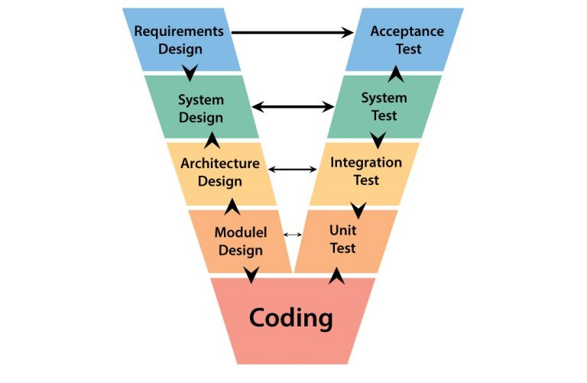](https://www.testbytes.net/wp-content/uploads/2017/12/V-model-in-software-testing-768x501.jpg)

**Figure No:[1] V-Model**

### 1.7 Project schedule

The project is distributed into several phases to do a calculated work. The work plan we include research about this system of how the system works. The overall working scenario of the project is shown in Gantt chat of the project.

## 

Table No:[1] Project Gantt chat

## 1.8 Project Report Structure

The project report contains the following chapters:

* Chapter 1 – Project Introduction
* Chapter 2 – Literature Review
* Chapter 3 – Proposed System Analysis
* Chapter 4 – Computer Languages and Tools
* Chapter 5 – Design and Implementation
* Chapter 6 – software testing
* Chapter 7 – Conclusion and Future Work

## 1.9 Conclusion

The broader view of the project is presented in this chapter, here the project aim usage, methodology, and objectives are discussed. The main objective of our project is to capture an unusual activity then store that activity on a local storage and the pictures on the online storage also to alert the concerned authorities

# Chapter 2

# Literature Review

This chapter discusses some existing system and also discuss that what the new improvement is started by our system.

## 2.1 Related Research

2.1.1 Surveillance system with computer vision:

Some psychophysical studies have emphasized limitations of human capability to monitor moving objects not only does employing human sources require costs but the chance of missing targets also increases with the growing number of monitor displays. Additionally, a non-automated system limits the area under surveillance, and consistent performance is hard to be achieved due to losing the attention of humans as monitoring time elapses.

* Numerous studies have been done based on people counting using computer vision, Here they present a solution to bidirectional people counting based on information provided by an overhead stereo system, four fundamental aspects are identified:
* The detection and tracking of human motion using an extended particle filter
* Use of 3-D measurements to increase the system's robustness
* Modified K-means algorithm is used to provide a deterministic output
* People trajectories are generated to perform people counting.

As a result, the stereo counting system produces a certain percentage of error. They are due to the following reasons:

2.2 Detection problem, Slow movement problem, deterioration problem:

It aims to develop an effective method for calculating the number of people and locate each individual in a low-resolution image with complicated scenes. Some people's counting system is based on face detection techniques. Since the camera is placed at the head height they present the people counting approach based on face detection; face trajectory an angle histogram of Neighbouring points is extracted. Finally, an Earth Mover's Distance-based K-NN classification discriminates true face trajectories from the false ones. In automated video analysis, object detection is based on background subtraction or DECOLORS Technique. DECOLOR outperforms the state-of-the-art approach and it can work effectively on a wide range of complex scenarios. In some systems, the manmade objects are captured in the radar which undergoes 3-D reconstruction. Two techniques proposed:

(1) MMV CS (multiple measurement vector compressive sensing),

(2) Regularisation theory. Framework based on the contour-based method for object detection. It deals effectively with contour tracking for videos with abrupt motions. It outperforms the particle filter-based algorithm. Automatic vehicle detection system for aerial surveillance, region-based or slidingwindow-based.

In the case of continuous video stream such as inAutomated Video Surveillance System, several methods exist for detecting motion and objects in the specific area. However, most of the approaches employ a similar strategy that is by comparing the frames from the current video stream against frames previously received or simply comparing it against the background frame. For object detection and recognition from continuous video streams, quite a several methods have been proposed in the past years. This includes background subtraction or frame differencing method, whichis often the preliminary step of detecting motion or object of interest. Other motion detection method that relies onimage processing and those that do not rely on imageprocessing usually employ on-body monitoring sensors.

One example of background subtraction is where light-independent background

subtraction is proposed. Disparityverification is used in this technique where this approach isinvariant to rapid changes in illumination, especially duringthe run-time. However, the biggest flaw of this technique happens when the object is moving slowly and smoothlywhere the relatively small changes in motion due to theframe differencing will only contribute to significantlyminute changes between frames. So, it is difficult to get thewhole moving object. There is also an instance when theobject is moving too slowly up to appoint that thebackground subtraction algorithms will not give any frame difference at all.

Another popular approach in acquiring a reliable frame asthe background is similar to finding the median of severalimages, where images are averaged over a period thus acquiring a static scene except where motion does occur.This could be very effective in situations where the backgroundis observable over a substantial period. However, thisapproach is not robust against scenes that involve fast-pacedmoving objects. This approach also depends on apredetermined threshold for the whole scene and cannothandle bimodal backgrounds. It also recovers slowly whenthe background is not affected by moving objects.

Alternatively, background subtraction can be carried outby comparing the current frame against the first frame fromthe continuous video sequence. Given that there is no objectin this initial frame, the problem mentioned above could beavoided. We can now acquire the whole moving object regardless of its moving speed. However, the biggest flaw ofthis approach could render the whole approach useless.Consider a situation where there is a vehicle in the firstinitial frame, and then it is gone. It will cause the algorithmto always detect motion at the place where the vehicle initially appears. This flaw can be reduced by continuouslyrenewing the initial frame after a certain interval of time, butstill, there is no guarantee that the newly obtained initialframe only contains a static background.

As mentioned earlier, motion detection usually serves as a basis for more advanced image processing tasks. Thus,normally the results from the background subtraction aretransmitted to higher-level processing such as objectdetection and object tracking. The information acquiredduring object detection could be used to improvebackground subtraction. In this case, pixel-based backgroundsubtraction decides whether the pixel belongs to thebackground (BG) or foreground object (FG) which is discussed using Bayesian [12], [13]. Assuming that the valueof a pixel at time t in RGB or some other Color space isdenoted by, the Bayesian decision R can be made asfollows

Additionally, the adaptive background proposed is carried outby analyzing the pixel-level approach. Using Gaussianmixture probability density, an efficient adaptive algorithmis proposed. The parameters are updated using recursiveequations and also to at the same time choose the propernumber of components for each pixel. Similarly, we use the Gaussian mixture probability density to analyze the motionat the pixel level.

There are numerous suitable approaches to executeBGS. The presence of several methods is due to severalcriteria. Still, some researchers concur on acategorization subject to the difficulties of the investigated “video sequence” in conjunction with thebackground description (Herrero &Bescós, 2009). Theappropriate BGS methods comprise of the following:

a) Kernel density estimation

b) A mixture of Gaussians

c) Frame differencing (Temporal median filter)

d) Running Gaussian average

e) Eigen backgrounds

f) Co-occurrence of variations in image

Although people still apply the BGS approaches, thereare challenges regarding them. These include camouflage amongst the foreground object(s) and the background, appearing in low-quality recordings,camera jitter, image noise, illumination changes, either sudden or gradual, among others.

# Chapter 3

# Proposed System Analysis

## 3.1 Introduction

After examining and studying different applications, we have identified different problems in those existing systems, like some of these are only providing detection, some of them store the videos from the starting time, some systems only save the videos without taking snaps, some of these systems don't support notifications alerts, Most of them don't have online storage system, so after studying these systems, we came up with a new idea of video surveillance system via motion detection for restricted areas which will overcome all these deficiencies with having functionalities like Storing the video only when an intruder enters the frame, Our system will also provide taking 5 Pictures when an intruder enters the frame, also it will be saved in online storage with a link sent with a notification alert which will be received when an intruder enters the frame and motion is detected.

3.2 Requirement analysis

Requirements Specification involves the complete behavior of the Application to be developed. It involves the functional, non-functional requirements of the system and constraints on the System under which the application will be developed.

### 3.1.1 Functional requirements

Functional requirements describe the functionality of a system as a whole or that of its component. These requirements form the software system in terms of the functions and functionality of the software system.

Following are the functional requirements of a video surveillance system via motion detection for restricted areas are:

* The system detect unusual activities storing the video when the motion is detected. Storing the video on a local disk.
* The system is developed in such a manner where 5 pictures will be taken when an intruder is detected in a frame.
* We developed the system in such a manner that is compatible with any sort of camera like webcam, internal cameras, IP camera, Mobile camera, etc.
* The pictures taken during the process will also be saved in online storage such as dropbox with a link generated.
* An alert will also be sent to the user with the link generated by the online storage of pictures taken during the process when motion is detected.

### 3.1.2 Non-Functional Requirement

Nonfunction requirements play an important role in this system, lack of these requirements might result in the system not working correctly and will not be considered as a quality product. The system can cause unfortunate events if not working properly so the following factors must be considered to avoid such issues and make the system more accurate.

3.1.2.1 Reliability :we developed our system in such a manner that it’s is more reliable.

3.1.2.1 Usability : we developed our system easy anyone can understand it.

3.1.2.1 Security : we made the system more secure by using the online storage option because no one can access it with out the user permission.

3.1.2.1 Supportability :our system can support by minimum system requirements such is CPU: Intel Core i5-4200M at 2.50GHZ

Memory: 8 GB  
Graphic Card: NVIDIA GeForce GT 740M  
Operating System: Window 8.

3.1.2.1 Stability :The proposed system is more stable on the mention above system requirements.

3.1.2.1 Portability: Our system is portable any one can used it on their system.

# Chapter 4

# Computer language and Tools

# 4.1 Python

In this project, we used python programming language, a high-level language for programming which performs its role in all kinds of platforms.This is relatively less complex compared to other programming languages as this takes only very little memory to execute the program. Also, Python deals very effectively with videos and image-processing than any other platform.Python is a programming language that lets you work more quickly and integrate your systems more effectively. We have used the python 3.9.6 version while programming this system.

### 4.2 OpenCV

We also used a computer vision library called OpenCV. Open-CV is an open-source software library for computer vision and machine learning, which is developed by Intel. The main advantage of Open-CV is to facilitate real-time implementation of computer vision with high accuracy. Open-CV provides a collection of software algorithms put together in a library to be used by industry and academic fields for computer vision applications and research. Open-CV supports from simple image processing practices to complicated machine learning algorithms.In the proposed system algorithm we used is taken from open-cv,from the capturing of camera function to the storing of video file taking of pictures and the applying of BGS algorithm these all are taken from open-cv. It could be used to detect objects, faces, and even human handwriting in photos and videos. The version we have used for open CV is 4.5.3.56.

### 4.3 Twilio API

We used Twilio API as a cloud communication platform, Twilio allows software developers to programmatically make and receive phone calls, send and receive text messages and perform other communication functions using its web service API, In this project, we are using the Twilio SMS function to get an SMS alert when motion is detected.

### 4.4 Dropbox API

Dropbox is a cloud storage service that lets you save files online and sync them to your devices, You can also use dropbox to share links of particular files. In this project, we used dropbox as online storage for the pictures taken to be uploaded when an intruder enters the frame and motion is detected.

### 4.5 Pycharm

For the development of this project, we used pycharm IDE which provides smart code completion, code inspection, on-the-fly-error, highlighting, and quick fixes along with automated code refactoring and rich navigation capabilities which is specially used for python language.

# Chapter 5

# Design and Implementation

## 5.1 Introduction

This chapter describes the design and implementation of the project. It briefly explains the project based on different diagrams.

## 5.2 Flow chart

A flowchart is a diagram that shows how a workflow or process works. A flowchart is a diagrammatic representation of an algorithm, or a step-by-step procedure for completing a task. The flowchart illustrates the steps as various types of boxes, with arrows linking the boxes in a logical order.

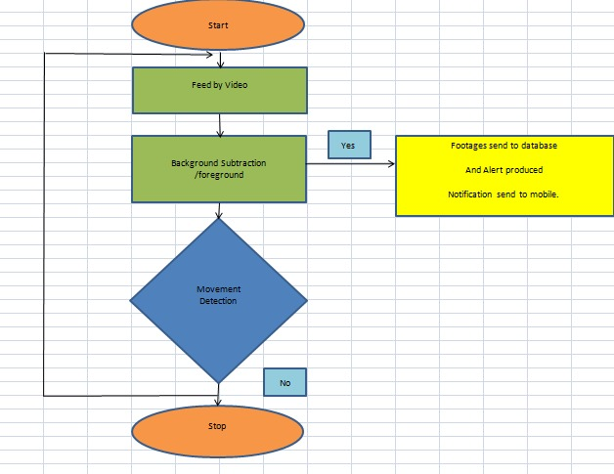Figure No:[2] Flow chart

## 5.3 Required permissions

* The produced system requires permissions for certain system features and to access the storage. The main purpose of the permission is to make sure the privacy of the users.
* The permissions contain accessing:
* The webcam when the user wants to use the system on an internal webcam.
* In case of using any external camera such as IP cameras, USB camera or mobile camera the access should be given from the application to these cameras
* The permission for local storage on the disk will be granted.
* The permission also needs access to dropbox for online storage.

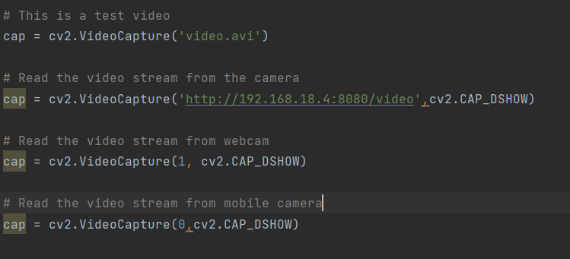

Figure No:[3]

The screenshot of the required permissions For different camera’s is shown.

## 

**Figure No:[4]**

**The screenshot of the required permissions For accessing local storage is shown.**

## 5.4 User Interface of Application

The user interface is the output of the system to which the user will interact.The following Screenshots show the user interface of our system.

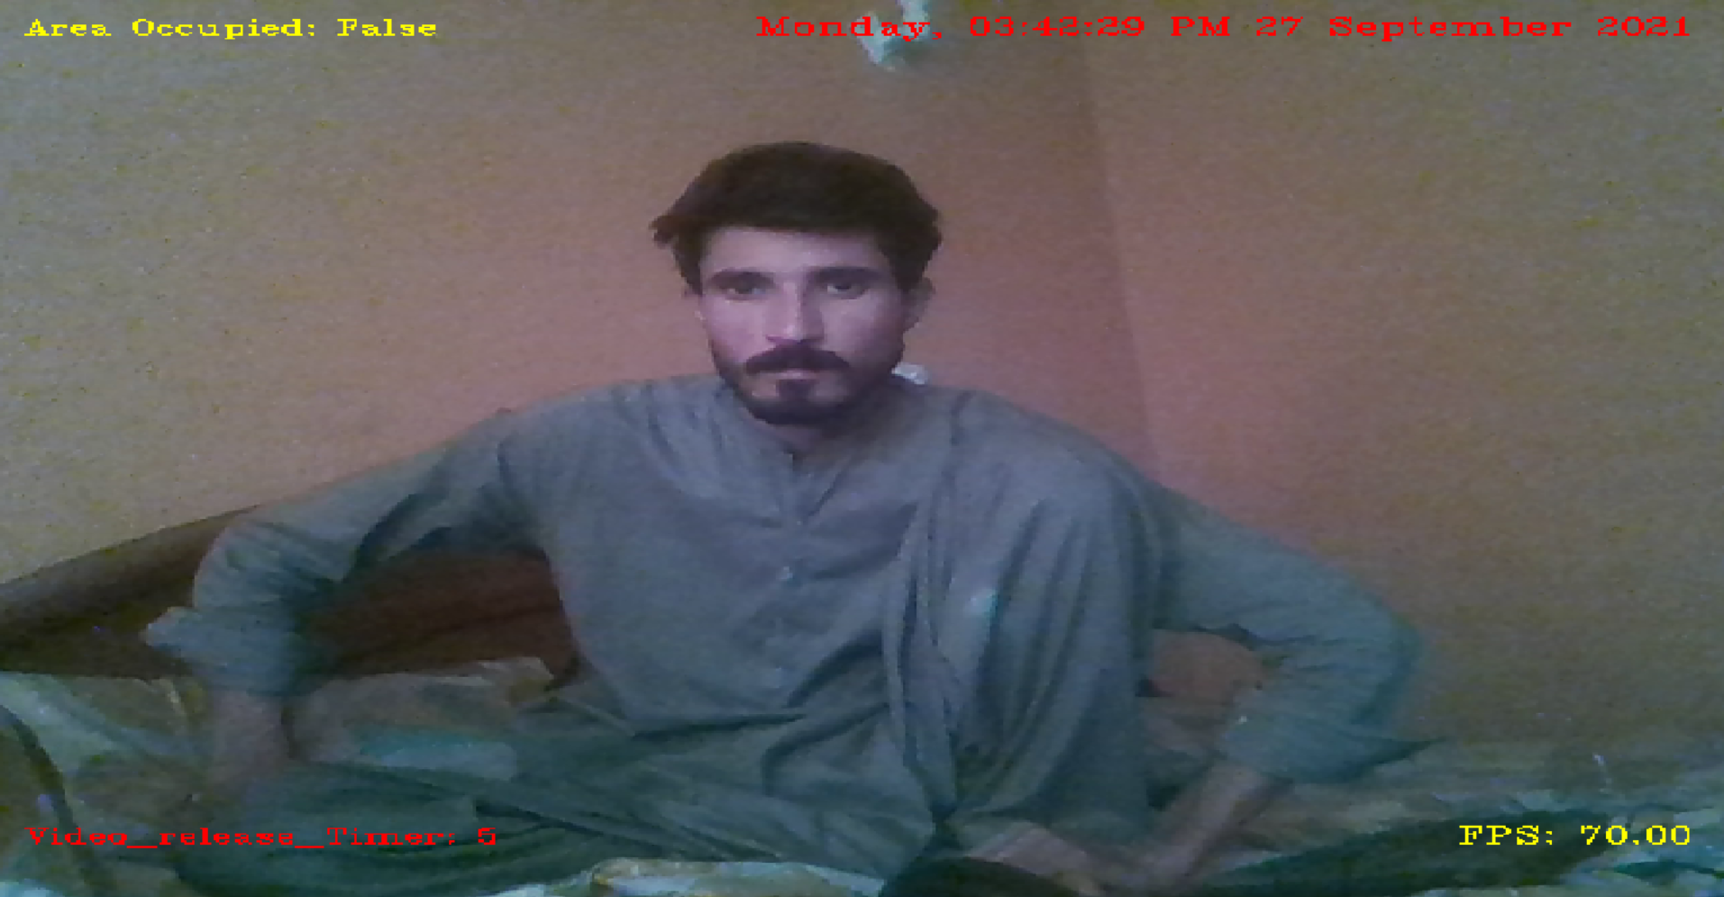

**Figure No:[5] User interface.**

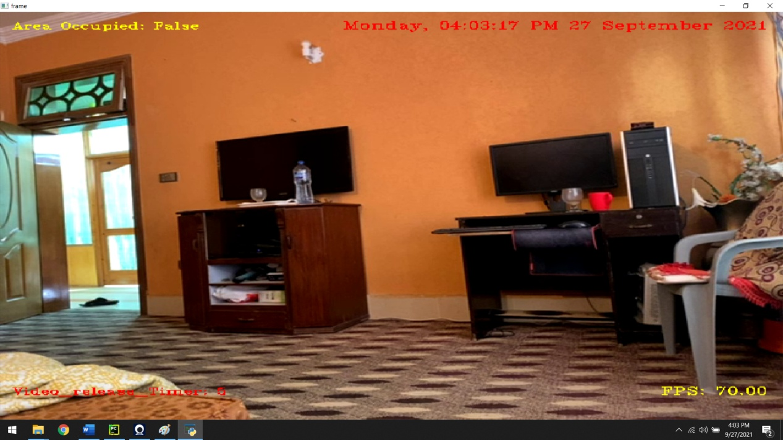

**Figure No:[5.1] User interface**

### 5.5 Video capturing

The OpenCV function "Video capture" imports image frames of real-time video streaming from a connected camera.

### 

### **Figure No:[6] Video capturing**

### 5.6 Interface of Intruder detected

While checking the system, when an intruder entered the frame and movement was detected, the following Figure shows the interface when an intruder is detected.

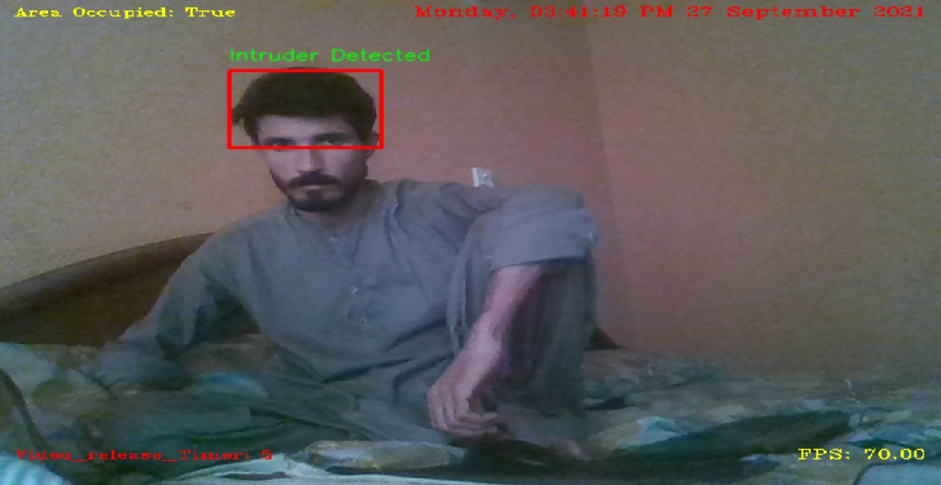

Figure No:[7] Interface with an intruder detected

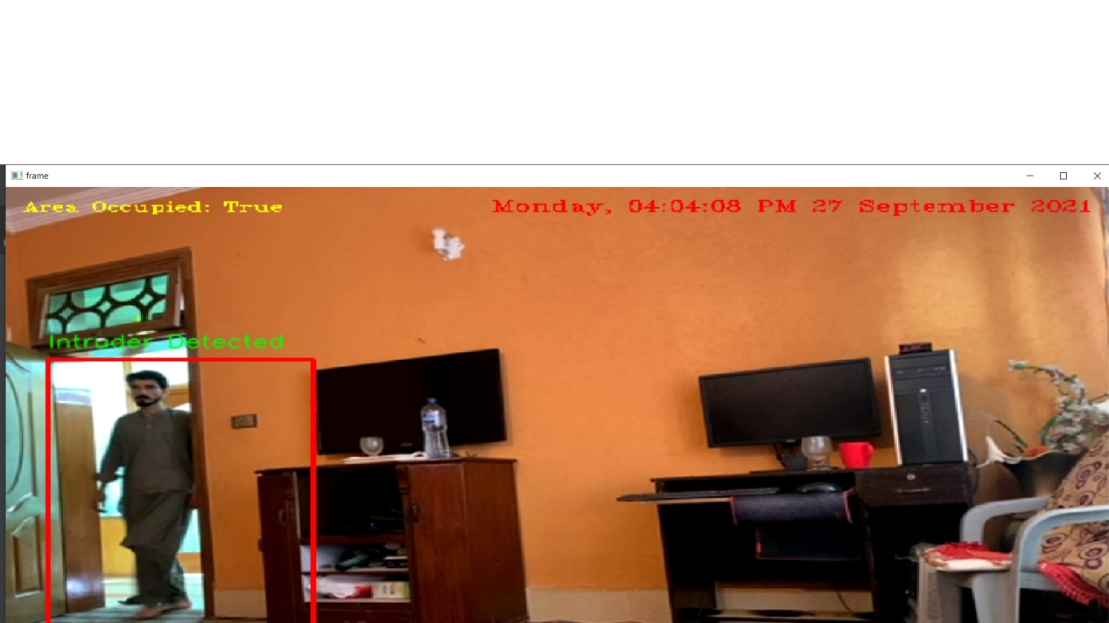

Figure No:[7.1] Interface with an intruder detected

### 5.7 Background Subtraction with contours in the frame

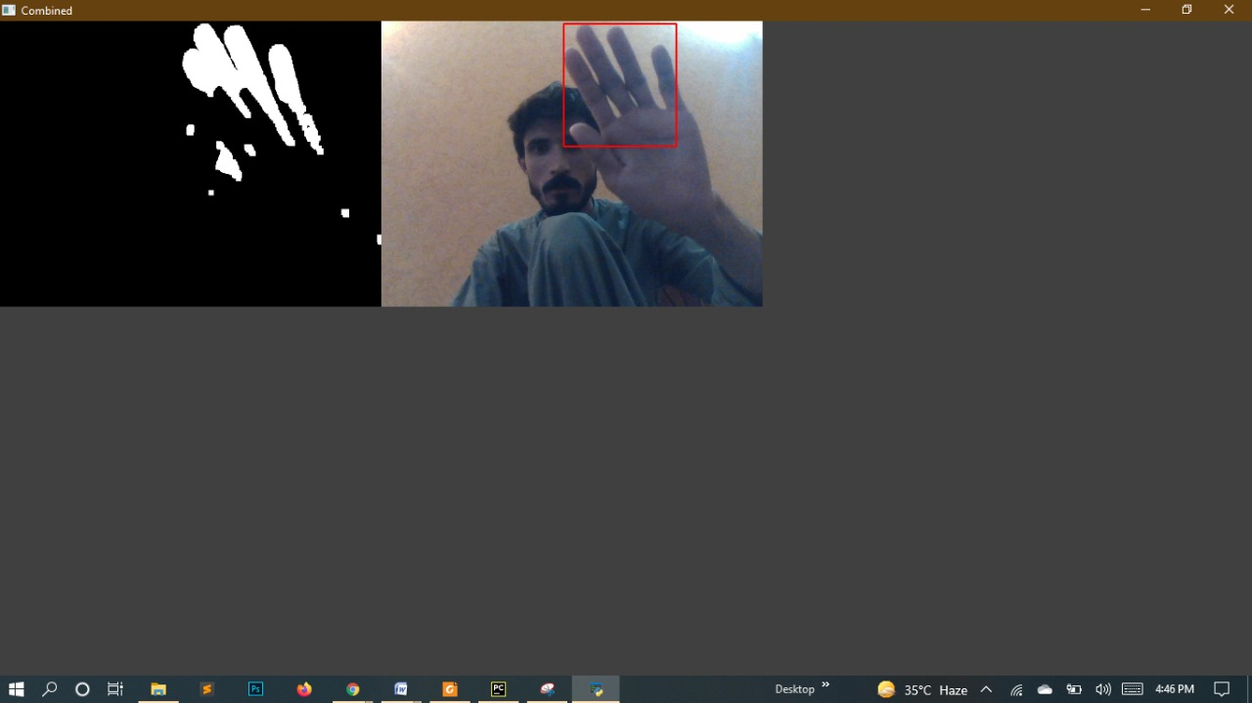

**Figure No:[8] Background Subtraction with contours**

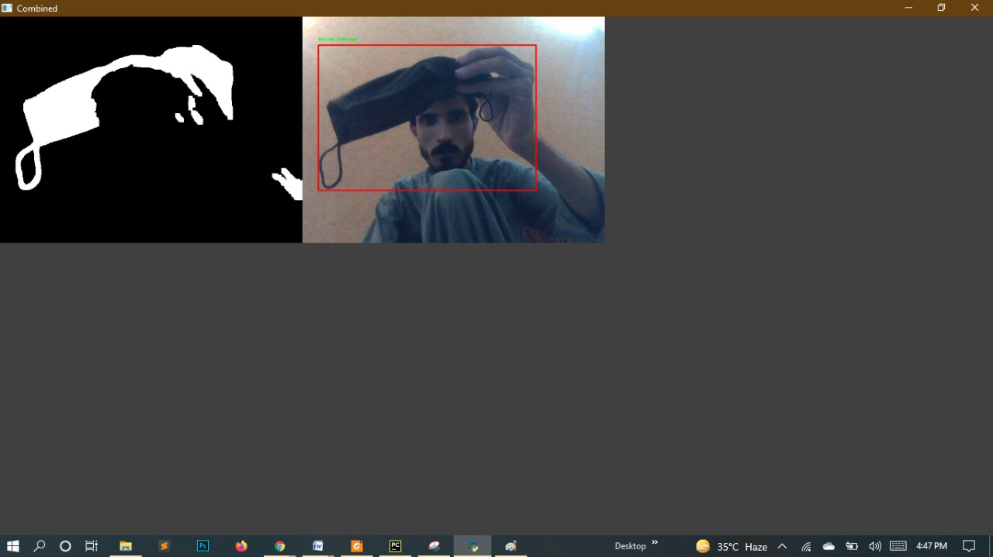

**Figure No:[8.1] Background Subtraction with contours**

### 5.8 Pictures Saved in local storage

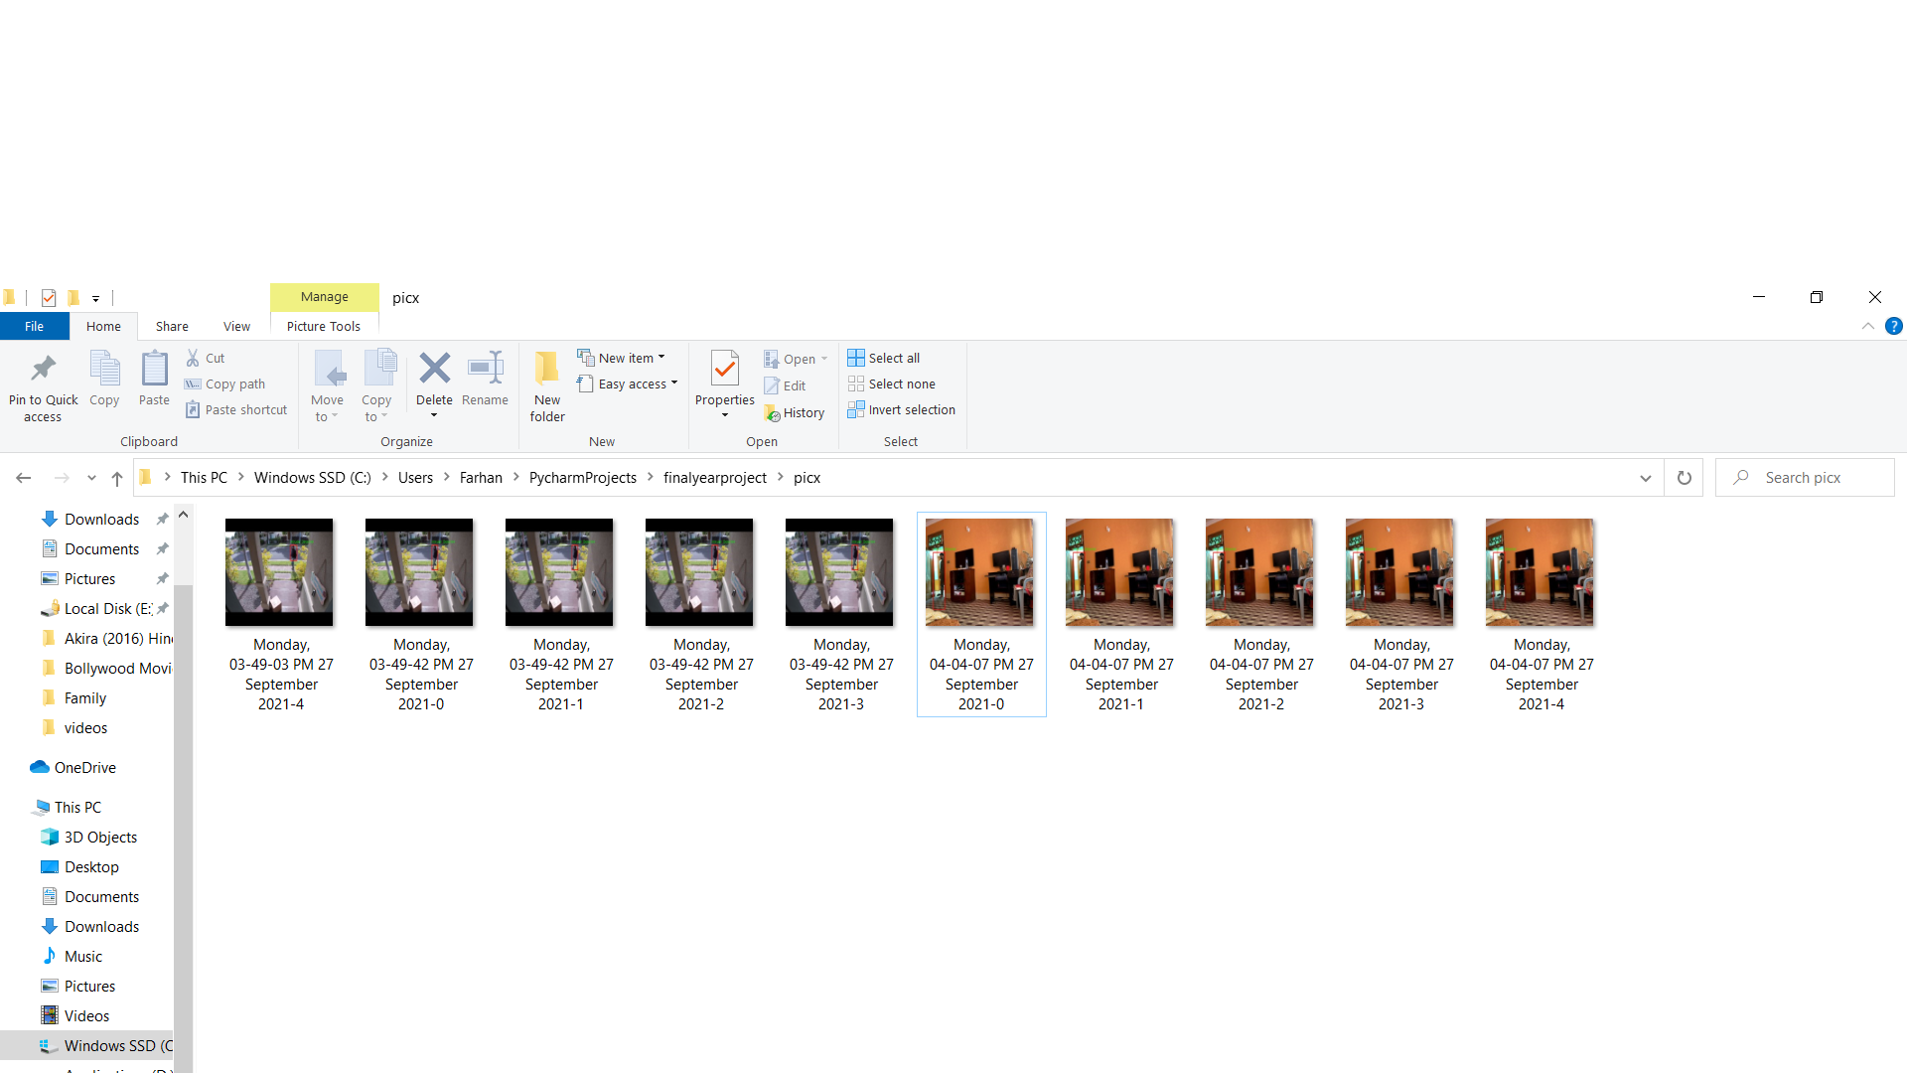The system will save 5 pictures when an intruder is detected and will be stored in local storage as shown.

**Figure No:[9] Pictures Saved in local storage**

### 5.9 Videos Stored in a local storage

When an intruder is detected the system will start the video until the intruder leave the frame and the video will be saved in local storage. 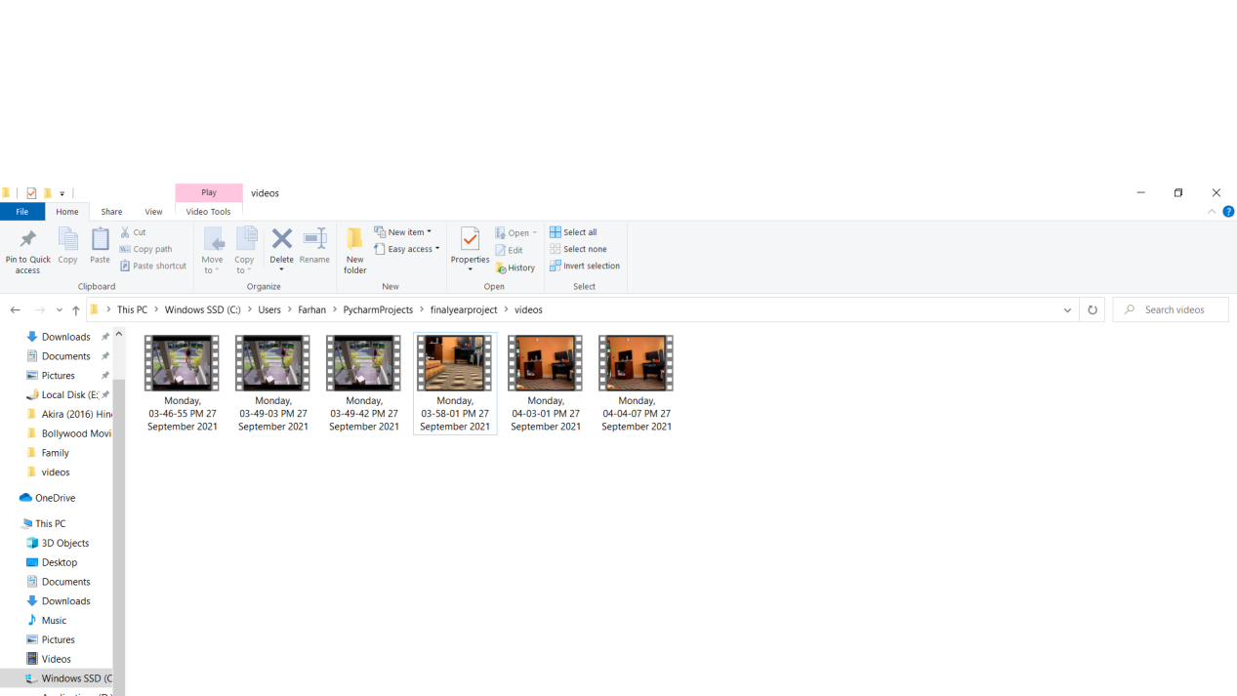

**Figure No:[10] videos stored in local storage**

### 5.10 Online Storage

In our system, we are using dropbox API as online storage, which will save the pictures for the user when motion is detected and will be accessible by a link generated.

The following figure shows the pictures uploaded when an intruder was detected.

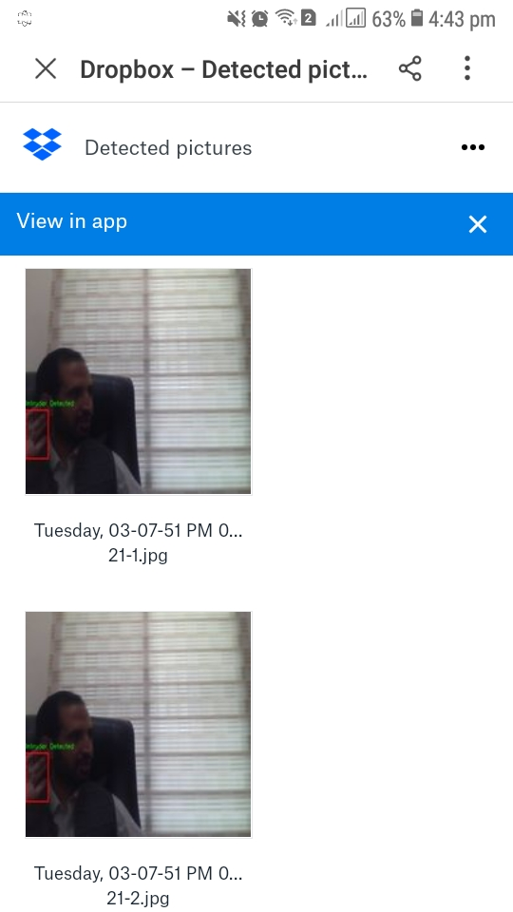

**Figure No:[11] Online storage**

### **WhatsApp Image 2021-09-27 at 4Figure No;[11.1]Saved pictures in Drop-box**

### 5.1.1 Sending Notification Alert

In this project, we are using Twilio API for sending an alert to the user when an intruder is detected along with the current timestamp and with the link of drop-box images saved.

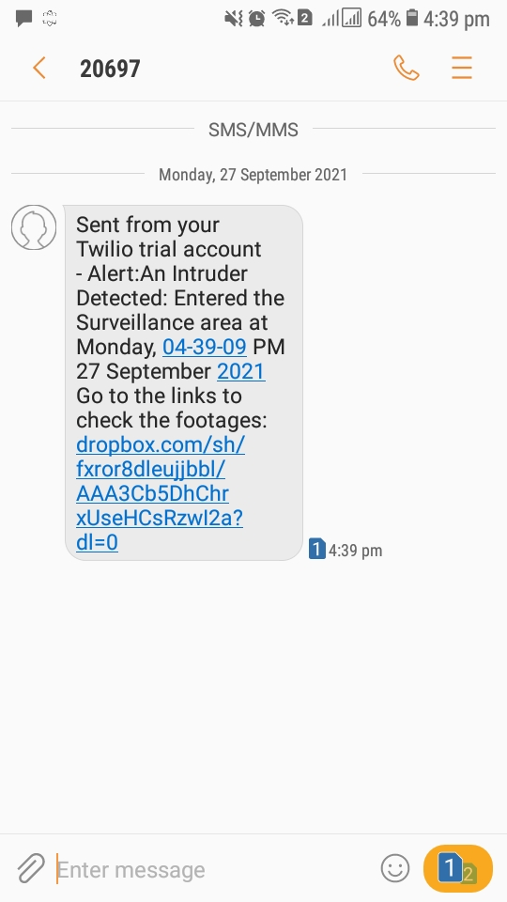

**Figure:[12] Notification alert from Twilio.**

# Chapter 6

# Testing and Evaluation

## Software testing

So basically software testing is an activity of testing software for defects and to ensure that the actual result of the software system is according to the expected result or the system is according to the requirement specified.

## Different types of Software testing

There are many different types of testing in software development. These techniques ensure that the software is working according to your expectations.

### 6.3 Load video Testing

We performed the load video test on the system to load a video from different sources such as a camera or a saved video. The system successfully loaded the videos from different sources without any errors and thus the test result was okay.

### 6.4 Black Box Testing

We performed a Blackbox test on the system to ensure the functionalities of the system without checking the internal structure of the proposed system and the result was successful without any errors.

### 6.5 End to End Testing

We performed end-to-end testing on our system to ensure the workflow of the application from beginning to end and to make sure that everything functions as expected. We tested our system and the result was successful without any errors.

### 6.6 Functional testing

We performed a functional test on our system to ensure that the system is doing exactly what it is supposed to be doing.We tested our system and the result was successful without any errors.

### 6.7 Non Functional Testing

We also performed nonfunctional testing on our system to check the non-functional aspects of the project like performance, reliability, accessibility, and security of the system and after the test, we didn't encounter any errors.

### 6.8 Performance Testing

In the performance testing, we examine the speed, stability, reliability, scalability, and resource usage of the software application under a specified workload, and thus our system was working smoothly without any issues.

### 6.9 Security Testing

In the security testing, we unveil the vulnerabilities of the system to ensure that the software system and application are free from any threats or risks. We have checked the system to find any potential flaws and weaknesses in our software system that could lead to a loss of data and we didn't find any security risk in the system.

### 6.10 Unit Testing

Unit testing is the process of checking small pieces of the code to ensure that the individual parts of the program work properly on their speeding of testing strategies and reducing wasted tests, we have checked our system unit by unit and the result produced by these tests were ok.

### 6.1.1 Integration Testing

Integration testing technique can be applied to the Application after the successful completion of unit testing, Integration testing is performed to check does the software component performs correctly and if they are correctly integrated with other components of the software. In our system, we have combined different components of the system and perform integration testing.

### 6.1.2 White Box Testing

White box testing involves testing the product's underlying structure, architecture, and code to validate input-output flow and enhance the design, usability, and security. We applied white box testing on the system and thus didn’t find any issue related to the mentioned above.

### 6.1.3 System Testing

We performed system testing on the system to check the whole system functionalities and thus we didn’t find any issue and the system was working correctly.

# Chapter 7

# Conclusion and Future Work

## Conclusion

After studying many existing systems, we realized that there are many deficiencies in those systems so we came up with an idea to overcome those deficiencies and make such a project which will have all the needed functionalities.

We proposed a surveillance system with real-time motion detection and tracking system in this paper. The system Employ different types of cameras as hardware and python API Open CV as a software application.

We propose an efficient approach to solve the aforementioned issues by modelling the scene's background and comparing each foreground frame to the background frame.In this surveillance method, the basic principle focuses on which the movement of a thing or a person can be found is through background subtraction. This is the primary method through which many security applications follow. Here, we take the consideration of two basic frames. They are the present frame and the previous frame. In this method, to find a movement, we subtract the previous one from the current frame. When this is done, obviously the change will be found. In this operation, when the background subtraction operation is done, pixel by pixel subtraction takes place. Through contours detection rectangle lines will be formed around the object. This is the reason for the difference between the two frames is observed as a movement.

The morphological operations erosion and dilation are applied on the frames to make the result positive and remove any errors regarding the detection of the moments.

To make the system more effective and efficient we combined several functionalities "Video surveillance system via motion detection for restricted area's" is usually a

Software-based monitoring system which, when it detects the motion will signal the surveillance camera to begin capturing the event or shows the motion detection using by taking 5 pictures of an intruder storing on local storage as well as on online storage using Dropbox API and sending a notification to the user using Twilio API.

The entire system consists of low-energy and less complex image processing techniques. Therefore, the system in this paper is considered a cost-effective solution for an unmanned surveillance platform that performs competitively compared to costly conventional systems.

## Future Work

In the future, this system can be improved through the implementation of an object classification model which will classify the object to be detected by the background subtraction algorithm whether the object is human, animal, or something else's.

Also, a proper user interface should be necessary for the system in the future from where the user can configure the settings of each function in the proposed project.

# References

[1] Gavrila, D, “The visual analysis of human movement: A survey,”

Proc. Computer Vision and Image Understanding, Vol. 73, pp. 82-98,

1999

[2] Xinyi Cui1, Junzhou Huang2, Shaoting Zhang1, and

DimitrisN,(2006).“Background Subtraction Using Low Rank and

Group Sparsity Constraints” Metaxa1 CS Dept., Rutgers University

Piscataway, NJ 08854, USA2 CSE Dept., Univ. of Texas at

Arlington, TX, 76019, USA.

[3] Jorge Garcia, Alfredo Garden, Ignacio Bravo, Jose Luis Lazar and

Miguel Martinez, (2013)“Tracking People Motion Based Extended.

[4] X. Zhao, E. Delleandrea, and L. Chen, (2009).“A people counting

system based on face detection and tracking in a video,” in Proc.

IEEE Int. Conf. AVSS, pp. 67-72.

[5] Xiaowei Zhou, Can Yang, and Weichuan Yu, (2013). “Moving

object Detection by Detecting Contiguous Outliers in the Low-Rank Representation" IEEE Trans.

[6] Wang. H and Suter.D, (2006). “A Novel Robust Statistical Method

for Background Initialization and Visual Surveillance” Proc.

Asian Conf. Computer Vision

[7] Nair.V and Clark.J,(2004).“An Unsupervised, online learning

framework for Moving Object Detection, "Proc.IEEE Conf.

Computer Vision and Pattern Recognition, vol. 2, pp. 317-324.

[8] box. T, Bruhn.V and Weickert.J, (2006).“Variational Motion

Segmentation with Level Sets, "Proc. European Conf. Computer

Vision. Surveillance refers from: http://news.linktv.org/topics/

surveillance

[9]Song, Y., "A perceptual approach to human motion detection and

labeling", Ph.D. thesis, California Institute of Technology, 2003

[10] H.A.M.El\_Salamony, H.F. Ali, and A.A. Darweesh, “3D Human Body

Motion Detection and Tracking in Video”, Proc. Acta Press

[11]. Javed O, Shah M. Automated video surveillance. Automated Multi-Camera

Surveillance: Algorithms and Practice. 2008:1-9.

[12]. Sulman N, Sanocki T, Goldgof D, Kasturi R, editors. How effective is human

video surveillance performance? Pattern Recognition, 2008 ICPR 2008 19th

International Conference on; 2008: IEEE.

[13]. Kalman RE. A new approach to linear filtering and prediction problems. Journal

of Basic Engineering. 1960;82(1):35-45.

[14]. Verstraeten C. OpenCV Simple Motion Detection [Available from:

https://blog.cedric.ws/opencv-simple-motion-detection.

[15]. Stein M. [cited 2017]. Available from: <http://www.steinm.com/blog/motiondetection-webcam-python-opencv-differential-images/>.

[16]Jana, S., &Borkar, S. (2017). Autonomous Object Detection and Tracking using Raspberry Pi, *7*(7), 14151–14155.

[17]Saravana Kumar K, Jestin Thomas, Jose Alex, Raag Malhotra.

Surveillance System Based On Raspberry Pi for Monitoring a Location Through A Mobile Device, International Journal of Advanced Multidisciplinary Research. 2015.2(3), 103–108.

# Copyrights Notice

This dissertation under the title “**Video surveillance system via motion detection for restricted areas**” is the intellectual property of **Kamran khan** and **Farhan khan**.

No part of this document may be reproduced, stored in any retrieval system, or used otherwise without the prior permission of the author. I hereby allow the University of Malakand to make copies of this dissertation for academic purposes only.

Any individual/organization may make copies of this document for non-commercial purposes with the prior permission of the author.

Kamran khan and Farhan khan

Department of Software Engineering

University of Malakand